The entire document must be written in 12-point Times New Roman font with 1.5-line spacing
Title (maximum 15 words)

Abstract
The abstract should be a single-paragraph summary of the most relevant aspects of the manuscript: introduction, objectives, methodology, results, and conclusions. It must not include discussion, citations, table references, or figures. The maximum length is 250 words for scientific articles and reviews, and 150 words for scientific or technological notes.
Keywords: This is a list of three to five keywords, either single or compound, separated by commas and not included in the title.

Resumen
This is the Spanish version of the Abstract, with the same content.
Palabras clave: This is a list of the same keywords, but written in Spanish.

Introduction

This section should present the problem related to the subject of study, as well as the state of the art, its relevance, originality, significance, the bibliographic background, the objectives, and the hypothesis of the work. In other words, the problem to be addressed must be precisely justified, avoiding generalities.
The background information must be based on relevant and recent scientific literature (at least 80 % of the citations should be no older than 10 years). The objectives must clearly specify and define the purpose and scope of the study; they should also be stated at the end of this section, match those presented in the abstract, and be consistent with the methodology and conclusions.

Materials and methods

This section should describe the most relevant and distinctive aspects of the study, providing sufficient detail to allow other researchers to replicate the work and verify the results. It must include the dates and locations of the study (with geographic coordinates and altitude), the factors and levels under research, treatment design, experimental unit and design, sampling schemes, variables evaluated along with their units and methods of measurement, materials, equipment (brand, model, country), reagents (brand, country), and techniques used, as well as experimental management, procedures, and statistical analysis methods. If sampling techniques are used, the sampling framework, sampling method, and procedures for obtaining estimators must be described. In cases where extensive methodologies are followed and can be found in manuals or specialized publications, the corresponding citation must be included. Any modifications to established or generalized methods must be explicitly stated.

Results and discussion

This section should consist of the results obtained or observations made as a result of the applied methodology, and must be presented in an orderly, complete, and concise manner. Tables and figures (e.g., diagrams, graphs, photographs) may be included and should be cited and placed in the appropriate location within the text. The information presented in tables and figures should not be repeated in the body of the text and must be self-explanatory, without requiring reference to the main text.
Elements derived from statistical analyses must be considered. This includes referencing the presence or absence of statistically significant differences, as well as the level of risk assumed by the researcher in making such claims. Where appropriate and relevant, interactions between the factors under study should be interpreted coherently. In addition to measures of central tendency, measures of variability, such as the coefficient of variation or standard error, should be included when pertinent.
The results obtained must be explained and discussed, including their relationship to the hypothesis and objectives, supported by comparisons with findings reported in relevant scientific literature. It is important to understand that merely presenting results is not sufficient; interpreting and discussing their meaning is mandatory. Excessive citations for a single idea should be avoided, as well as discussing unrelated published literature.
Information already presented in the “Materials and methods” section should not be repeated, nor should the writing resemble a literature review. All analyzed variables and methods must have been described in the “Materials and methods” section. Below is an example of a figure and some tables.
Each figure must have a legend placed below it, beginning with the word “Figure” followed by its corresponding Arabic numeral in the order it appears in the manuscript. The remainder of the figure caption should be written in regular font. Figure titles must be included as text and should not be embedded within the image.

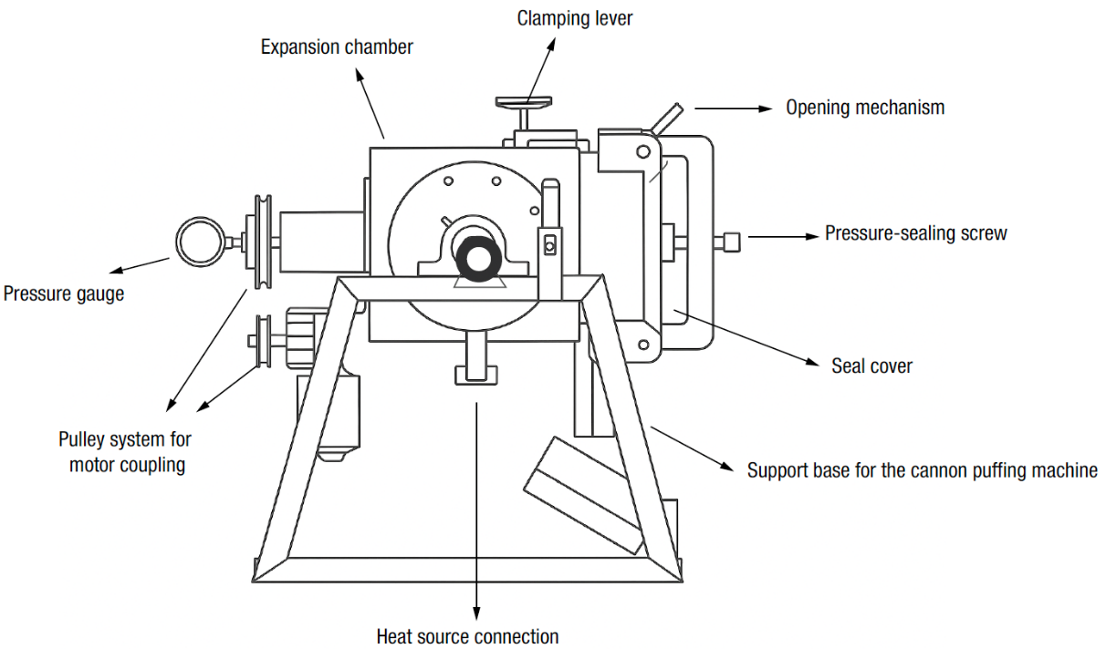
Figure 1. Diagram of the cannon puffing machine manufactured by the Centro Nacional de Estandarización de Maquinaria Agrícola, Instituto Nacional de Investigaciones Forestales, Agrícolas y Pecuarias, Mexico. Source: Own elaboration.

In the case of tables, it should be noted that only three full horizontal lines (spanning the width of the table) are included. Table 2 includes an additional line, which is only acceptable as a segment to separate concepts. As with figures, the word “Table” must appear in bold, followed by the corresponding Arabic numeral according to its order of appearance in the manuscript. The remainder of the table title should be in regular font. The title must be placed above the table and should not be included within a cell.
In tables presenting analysis of variance, the mean squares for the variables should be reported without units. If analysis of variance was conducted but the corresponding tables are not included, the sources of variation that were statistically significant must be described in the text, along with the coefficients of variation for all variables evaluated.

Table 1. Mean squares from the analysis of variance for yield and water use efficiency (WUE) in the cotton crop.
Source of variation | DF | Yield | WUE
Blocks | 3 | 0.1817 | 0.0025
Treatments | 6 | 6.1167** | 0.0698**
Error | 18 | 0.0893 | 0.0014
Total | 27
CV |  | 4.29 | 4.86
DF: degrees of freedom; CV: coefficient of variation; **: significant with p ≤ 0.01.

Regarding mean comparisons, these should be performed only when the analysis of variance indicates statistically significant differences in the traits studied and for the specific sources of variation. This recommendation is because, under the assumption of normal distribution, the analysis of variance test is less susceptible to error than multiple mean comparison tests. Hypothesis testing can be conducted based on the analysis of variance results. Coefficients of variation enable comparison of the variability observed in response variables to that reported in other studies.

Table 2. Mean comparisons of puffed quality variables in conditioned native maize processed with a cannon puffing machine.
Genotype | EV (cm³∙g⁻¹) | UPK (%) | MS (%) | BS (%) | Moisture (%)
Toluqueño | 19.45 b | 2.85 b | 8.64 c | 79.6 a | 2.97 b
Arrocillo | 21.14 a | 0.36 b | 26.86 a | 69.5 b | 5.07 a
Chapalote | 17.43 c | 19.44 a | 18.13 b | 57.2 c | 5.0 a
HSD | 1.35 | 2.9 | 7.73 | 8.36 | 0.32
EV: expansion volume; UPK: unpuffed kernels; MS: mushroom shape; BS: butterfly shape; HSD: honestly significant difference. Different letters in each column indicate significant differences (Tukey, p ≤ 0.05).

Conclusions

This section must present, clearly and concisely, the key statements derived from the results and discussion. The conclusions should remain strictly within the scope of the study and must not constitute a summary of the results. Each conclusion must be directly aligned with the study’s objectives and hypotheses and should reflect only the findings that were empirically demonstrated. The inclusion of hypotheses, assumptions, or speculative interpretations is not permitted. Recommendations should be avoided unless explicitly stated as an objective of the research. This section must not include tables, figures, references, or citations. A maximum length of 150 words is recommended.

Acknowledgments
This section should include recognition of individuals, institutions, funding bodies, research grants, or any other entities that provided meaningful support or collaboration during the development of the study. To ensure a double-blind review, the authors' names should not be included.

Conflict of interest statement
Authors must disclose any conflicts of interest that could inappropriately influence or bias the outcomes of the study. In such cases, the following statement should be included:
The authors declare the following financial interests (or personal relationships) that could be considered potential conflicts of interest: [LIST CONFLICTS], which were addressed through [AGREEMENTS].

If no conflicts of interest exist, the authors should include the following declaration:
The authors declare that we have no known financial conflicts of interest or personal relationships that could have influenced the research presented in this article.

Declaration of Artificial Intelligence (AI) Use
If generative AI or AI-assisted technologies were used in the development of the manuscript, the authors must provide a brief description, for example:
During the preparation of this work, [NAME OF TOOL/SERVICE] was used for [REASON]. All material obtained with this technology was reviewed and edited, so the authors assume full responsibility for the content of the published article.

If generative AI or AI-assisted technologies have not been used, the authors must declare this; for example:
The authors declare that we have not used generative AI or AI-assisted technologies for the development of this manuscript.

The generation of results, discussions, conclusions, or the creation or modification of images in the manuscript using AI is forbidden.

References
All bibliographic references cited throughout the manuscript must be presented in accordance with APA 7th edition guidelines (http://www.apastyle.org). Make sure that all references cited in the text appear in the reference list, and all entries in the reference list are cited in the text. All references must include their DOI (Digital Object Identifier: www.doi.org) or, if unavailable, a direct URL where the source can be accessed. An APA 7 reference guide is available on the journal’s website.
All references must be from primary sources; references to secondary sources (i.e., “cited in”) are not accepted under any circumstances. References from theses, brochures, abstracts, conference proceedings, or any other publications with limited circulation are also not allowed. Internet citations are not permitted, except when they refer to statistics or yearbooks published by official organizations; in such cases, the date of access must be provided. References should be current (last 10 years), and whenever possible, should represent 80 % or more of the total sources consulted.
If a reference management program is used, all field codes must be removed before submitting the manuscript:
- In your Word document, press Ctrl + e to select all content.
- Press Ctrl + 6 or Cmd + 6 to unlink all fields and remove hidden links.

Castillo-García, O., García-Mateos, M. R., Castillo-González, A. M., Ybarra-Moncada, M. C., & Hernández-Ramos, L. (2025). Nutraceutical and nutritional characteristics of capulin segregants (Prunus serotina) fresh and processed. Current Topics in Agronomic Science, 5, e2402. https://doi.org/10.5154/r.ctasci.2024.05.02
Food and Agriculture Organization of the United Nations (FAO). (2024, July 13). Countries by commodity. FAOSTAT. https://www.fao.org/faostat/en/#rankings/countries_by_commodity_exports
Foster, A. P. (2025). Deer veterinary medicine. Wiley & Sons Ltd. https://doi.org/10.1002/9781394221370
Mounir, S., Ghandour, A., Farid, E., & Shatta, A. (2023). Popped and puffed cereal products. In M. A. Shah, K. V. Sunooj, & S. A. Mir (Eds.), Cereal-Based Food Products (pp. 169-196). Springer. https://doi.org/10.1007/978-3-031-40308-8_8
SAS Institute, Inc. (2018). User’s guide (ver. 9) [software]. SAS Institute, Inc. https://www.sas.com/es_mx/home.html

